ASSIGNMENT 7.1
Name : Uma Maheshwari
2303A52430
Batch : 44
Task 1: Provide a Python snippet with a missing parenthesis in a print
statement (e.g., print "Hello"). Use AI to detect and fix the syntax
error.

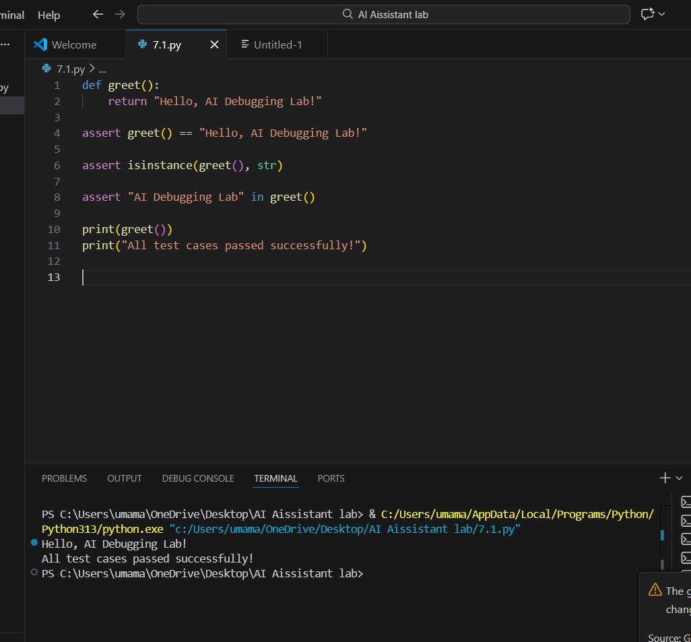

Task 2: Supply a function where an if-condition mistakenly uses =
instead of ==. Let AI identify and fix the issue.
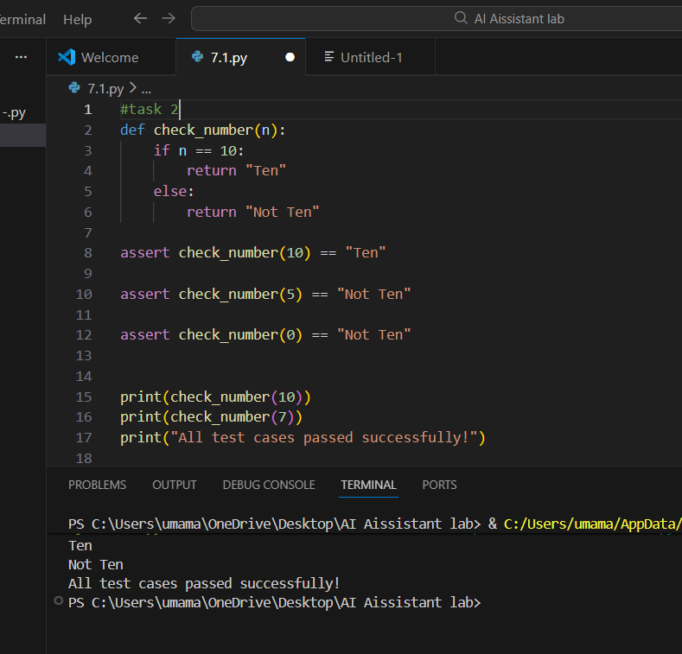

Task 3: Provide code that attempts to open a non-existent file and
crashes. Use AI to apply safe error handling.
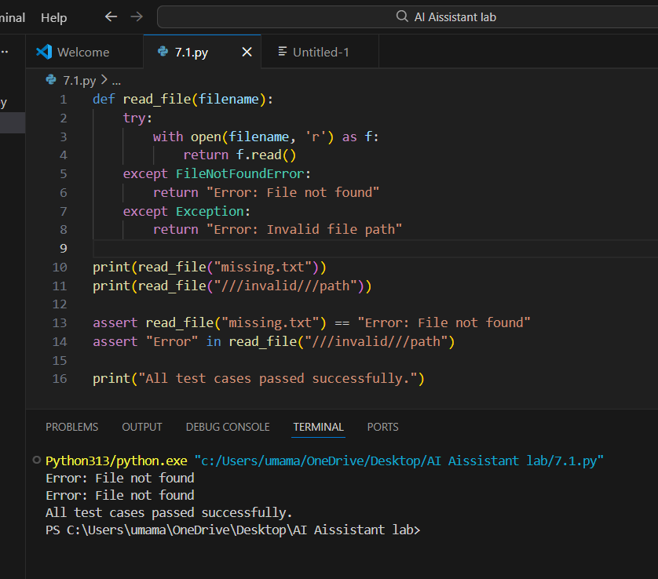

Task 4: Give a class where a non-existent method is called (e.g.,
obj.undefined_method()). Use AI to debug and fix.
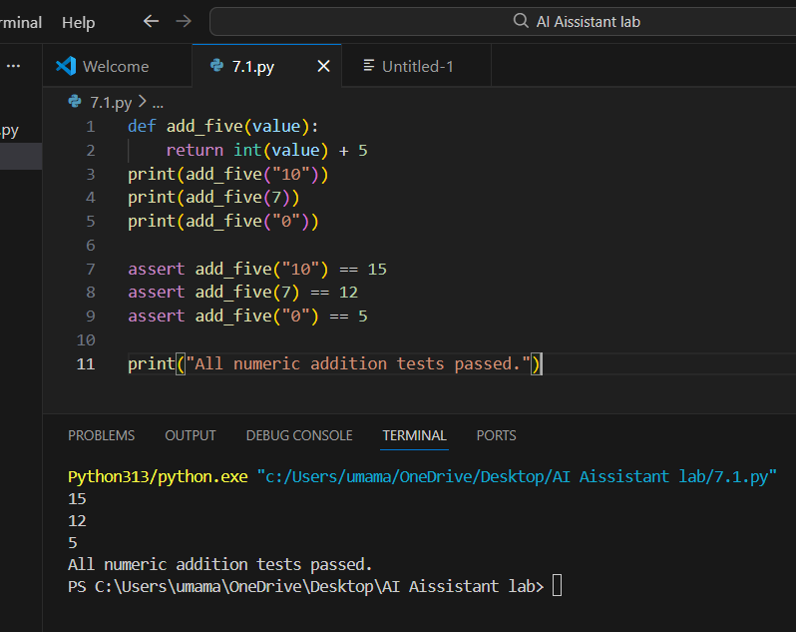

Task5: Provide code that adds an integer and string ("5" + 2) causing
a TypeError. Use AI to resolve the bug.
